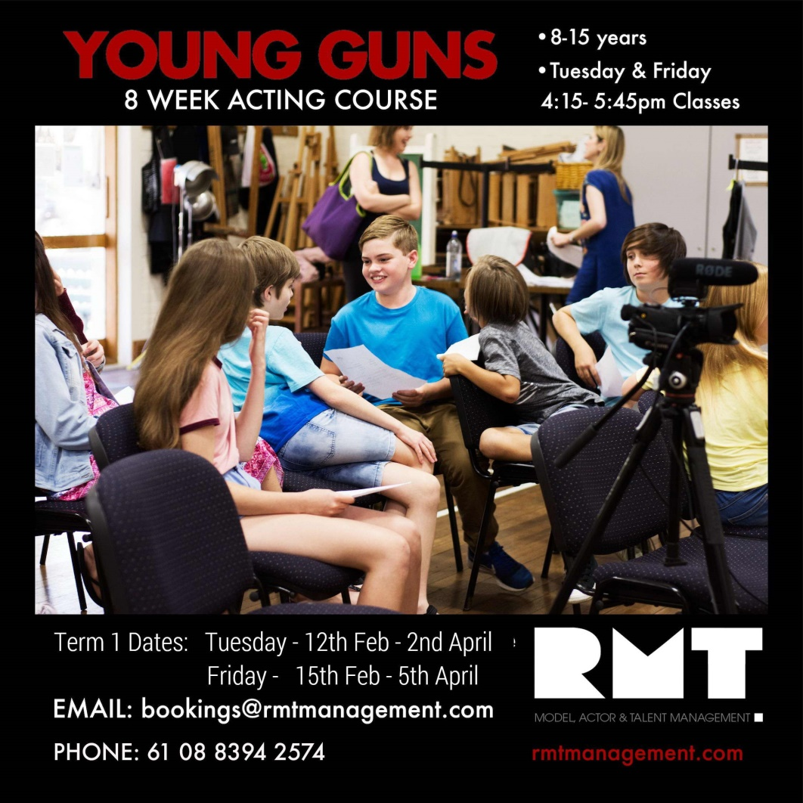

* Acting, audition & performance training for stage & screen
* 8-13 years *(caters for beginners & advanced students)*
* An ongoing program throughout the school year
* Tuesdays 4pm – 5:30pm
* Term 1 - 9th Feb 2021 – 30th March 2021
* Fullarton Park Community *Centre*

*(411 Fullarton Rd, Fullarton)*

* Professional actor representation provided *(optional)*

Email: [admin@rmtmanagement.com](mailto:admin@rmtmanagement.com)

Phone: 08 8394 2574

**YOUNG GUNS YOUTH ACTING PROGRAM**

8

Contact:

* Email: [admin@rmtmanagement.com](mailto:admin@rmtmanagement.com)
* Phone: 08 8394 2574